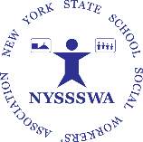
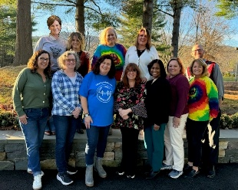
Ever Wondered What NYSSSWA
Does for You?
NYSSSWA Board
We have compiled this document to highlight some of the activities that the New York State School Social Workers’ Association has been involved with to support and advocate for School Social Workers (SSWs) across the State of New York. Your membership and investment in our profession made this all possible! Thank you.
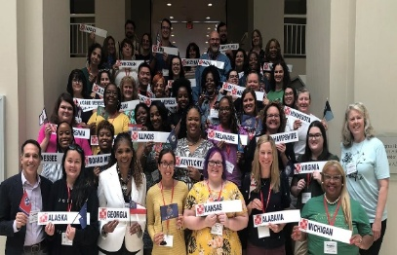
Support to Members:
- Provided representation at the national level with the School Social Work Association of America.
- Continued to provide members with on-line community resources.
- Continued to develop and update web pages to provide numerous resources to assist SSWs in their daily work.
- Provided newsletter and electronic news updates.
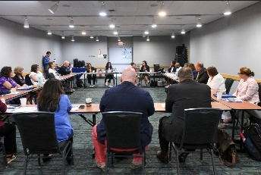
- Continued to expand Social Media presence.
- Provided technical assistance to members.
- Meet with state leaders to promote SSW services.
- Established a University Liaison position on the Board.
- Provided opportunities for networking and problem solving.
NYSSSWA Regional Development
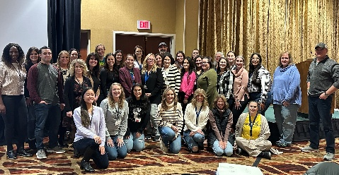
- Increased Regional Representation to the Board for the Genesee/Rochester, Nassau/Suffolk, New York City & Northern regions.
- Continued recruiting efforts for regions currently not represented. If you are interested in representing your region, let us know at member.services@nyssswa.org .
Advocacy
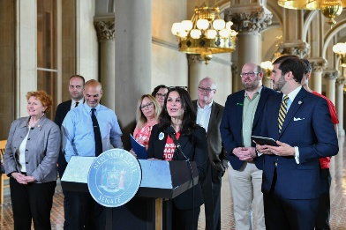
- New York General Assembly
  - NYSSSWA met with legislators throughout the year to advocate for increased School Social Workers and services to students.
  - NYSSSWA participated in last year’s “Advocacy Day”.
  - The Board accepted the invitation to Senator Andrew Gounardes’ and Assembly Member Jo Anne Simon’s event to support their Lockdown Drill Reform bill.
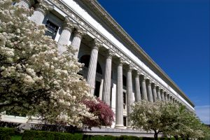
- New York State Education Department—NYSED
  - Continued ongoing discussions and SSW advocacy with Evan Seiden, Executive Secretary to clarify the regulations for obtaining supervision in the school setting to obtain licensure.
  - NYSSSWA Committee continues to meet to develop documents that will outline step by step procedures for receiving supervision in schools in order to obtain an LCSW.

- Student Centered Support Services (SCSS) – “The Collective Care Team”
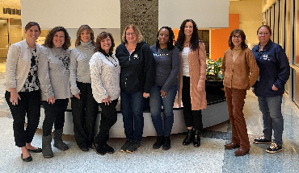
  - Attended quarterly meetings held with the presidents of NYSSCA, NYASP and NYSASN (State associations for School Counselors, School Psychologists & School Nurses).
  - Group is working to narrow legislative focus as well as strategies to advocate jointly as a team on issues impacting services to students.
  - Group reached out and obtained lobbying support from the New York State United Teachers (NYSUT)
  - On May 7, 2024, NYSSSWA joined our “Collective Care Team” members for Advocacy Day hosted by NYSUT to meet with Senators and Assembly staff to advocate for (4) bills that were currently in the legislature.

- Mental Health Association in New York State (MHANYS)
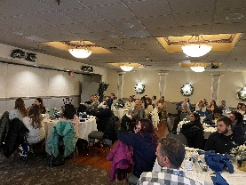
  - Networked with other local and state organizations.
  - Discussed resources available to SSWs and school staff.
  - MHANYS’s Western group provided a joint presentation in May to Buffalo Region SSWs
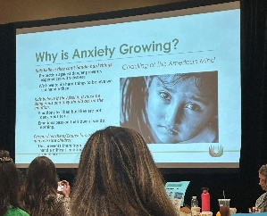
Professional Development:
- NYSSSWA’s 2024 State Conference at The Sagamore Resort on Lake George was the largest attended State Conferences to date!
- Mohawk Valley -- Spring Conference, 2024 Fall Event.
- Nassau-Suffolk Region – Spring Event
- NYC – 2024 Fall Event
- SSWAA Conference – (NYSSSWA provided New York approved Continuing Education credits for the School Social Work Association of America’s (SSWAA) National Conference in 2024 and will continue to supply CEs for the 2025 National Conference in Atlanta.
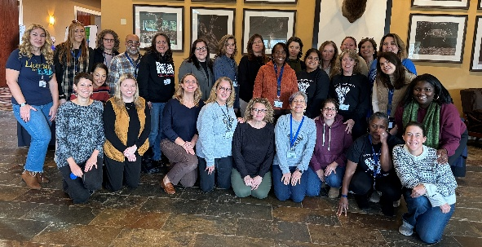
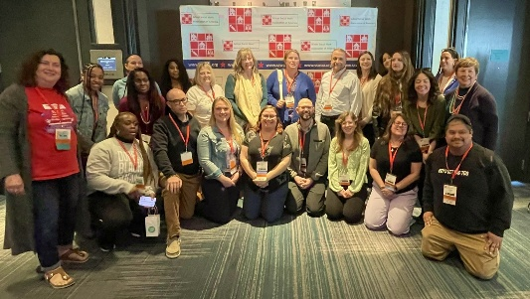
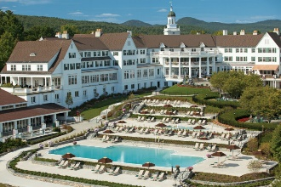
- Western Region Spring and May Conferences.

