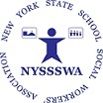
Meet the NYSSSWA Board:
Dr. Krystal Folk-Nagua
New York City Regional Representative

dd

