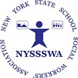
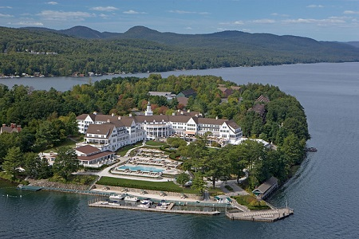
Call for Workshop Proposals - 2023

Share Your Expertise

New York State School Social Workers’ Association

We know School Social Workers across New York are doing fabulous things to assist students. This is your opportunity to submit a proposal to be part of the 58th School Social Work State Conference which is sponsored by the New York State School Social Workers’ Association. If you are interested in presenting a Webinar some time, let us know that too! The State Conference will be held at Lake George at The Sagamore Resort beginning on Thursday November 2 to Friday November 3, 2023. Don’t delay. Workshop Proposals are due by June 1, 2023!

Top Topics of Interest Include*:
- Attention Deficit Hyperactive Disorder
- Child & Adolescent Mental Health Issues
  - Anxiety
  - Depression
  - Suicide Prevention & Risk Assessment
- Diversity, Equity, and Inclusion
- Interventions & Strategies
  - Attendance
  - BEHAVIOR MANAGEMENT*
  - Crisis Response & Management
  - Practical Tools SSWs Can Use*
- LGBTQIA+
- Self Care
- Social Media*
  - Impact on Children & Youth
  - Safety Concerns--FBI
- Threat Assessment

Other Topics of Interest*:
- Art Therapy
- Child & Adolescent Mental Health
  - Eating Disorders
  - First Aid
  - Panic Attacks
  - Tech Addiction and the Effects on Young People
- Dialectical Behavioral Therapy
- Eating Disorders
- Homeless Liaison—Effective Practices
- Multi Tiered Systems of Support
- Restorative Practices
- Teen Violence
- Trauma Sensitive Schools
- Yoga

*Topics based on 2022 attendee feedback. **Topics that received the most requests.

Visit our website to obtain a copy of the Workshop Proposal as well as detailed information regarding St. George attractions, The Sagamore Resort, etc. at: https://nyssswa.org/2023nyssswa-state-conference/

Help us provide a fabulous Conference and Professional Development. Take time to submit your proposals today!

Wendy Castiglia, Conference Chair wendy.castiglia@nyssswa.org
Dot Kontak, Director of Communications dot.kontak@nyssswa.org
New York State School Social Workers’ Association

