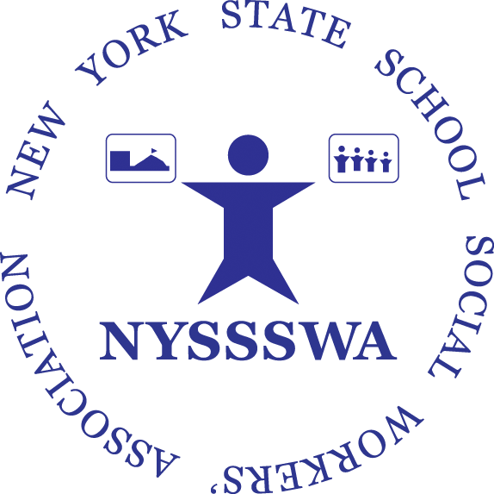
WORKSHOP PROPOSAL

New York State School Social Workers’ Association

Title of workshop: ____________________________________________________________________

Subject/topic of the course/educational activity: _____________________________________________

Attach a workshop description of not more than 100 words that can be used as an abstract for the conference brochure/flier as well as three learning objectives.
Description of course/educational activity content: ___________________________________________

_____________________________________________________________________________________

_____________________________________________________________________________________

_____________________________________________________________________________________

_____________________________________________________________________________________
Three (3) Learning objectives (measurable) of the course/educational activity:

_____________________________________________________________________________________

_____________________________________________________________________________________

_____________________________________________________________________________________

_____________________________________________________________________________________

_____________________________________________________________________________________

Description of the teaching methods to be used and if any audio/visual/computer equipment is required and/or special seating or space requirements are need.

____________________________________________________________________________

____________________________________________________________________________

I am willing to do an In Person Presentation: □ Yes □ No
I am willing to do a Virtual Presentation. □ Yes □ No

Length of Workshop: □ 1.0 Hour □ 1.5 Hours □ 2 Hours □ 3 Hours

Target Audience: □ Pre-School □ K-12 □ Elementary □ Middle □ High School

Practice Level: □ Beginning □ Experienced

Presentation Style: □ Lecture □ Panel □ Experiential □ Other ______________________

PRESENTERS: Please provide a curriculum vitae or resume for EACH instructor that: (1) demonstrates his or her qualifications to conduct the course(s)/educational activities; and (2) includes at least his or her: (a) name; (b) current employment title; (c) degree(s) earned, with name and location of institution, major, and date received; (d) licensure status (if applicable); (e) evidence of expertise on the topic (f) teaching experience; and (g) previous professional positions.

Primary Resume’ and/or vitae required from all presenters. Presenter: ____________________________________ Degree/Credentials:____________
Email:_______________________________________________________________________________

Employer:____________________________________________Position:_________________________________

Have you presented before? Where? ______________________________________________________
Have your trainings been previously approved for SW CEUs by the NYSED Office of Professions?
No ____; Yes____ Please indicate for whom and when: __________________________________
_____________________________________________________________________________________

Additional Presenter:___________________________________Email:___________________________________

Additional Presenter:___________________________________Email:___________________________________

SPEAKER FEE: NYSSSWA is a small organization with a very limited budget. Please let us know what your reimbursement expectations may be, if any i.e. fee, lodging, travel: ___________________________________________________________________________________________
____________________________________________________________________________________________
____________________________________________________________________________________________

*************************************************************************************

Please send completed form and resumes to Dot Kontak, Director of Communications & Membership Services at Dot.Kontak@nyssswa.org

Thank You.

