2021 Virtual Conference - TRACKS
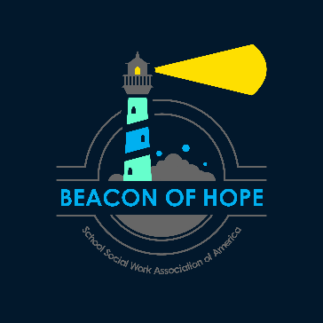
The 2021 SSWAA National Conference will be presented virtually. All General Sessions will be presented in Track 1 / Room 1. All Special Presentations will be presented in Track 1 / Room 1. During Breakout Session time slots, attendees of the live event will be able to choose from the session in Track 1 / Room 1 or the session in Track 2 / Room 2. Please see the chart below to help you navigate the live event. *Please note: a link will be provided on the bottom of the Track 1/ Room 1 page which links to Track 2 / Room 2 and vice versa. Please use these easy links to navigate between rooms.

Pre-Conference
Monday, March 22
6:30pm – 8:30pm Eastern (two options) 2.0 CEUs

Track 1 | Track 2
Pre-Con Session A: Trauma-Informed Forum | Pre-Con Session B: SEL Forum

Full Conference
Tuesday, March 23

Time | Track 1 | Track 2
10:00am – 11:00am | General Session – Ethical Recordkeeping | No session
11:15am-12:45pm | A1: Building Belonging | A2: Fine-Tuning Cultural Competence
LUNCH | Sponsor Information | No session
1:15pm-2:45pm | B1: Developmental Assets | B2: SSWers as Border Crossers
3:00pm-4:30pm | C1: Impact of Trauma on Immigrants | C2: The Art of Advocacy
4:30pm-5:00pm | Special Award Presentations | No session

Wednesday, March 24

Time | Track 1 | Track 2
10:00am – 11:00am | General Session – Discipline and PBIS | No session
11:15am-12:45pm | D1: Supporting Students through Grief | D2: An African-Centered Approach
LUNCH | Sponsor Information | No session
1:15pm-2:45pm | E1: Art Based Interventions | E2: LGBTQ+ Youth Panel
3:00pm-4:30pm | F1: Risk and Protective Factors | F2: Faith & Mental Health
4:30pm-5:00pm | Closing Announcements | No session

*Please see the Conference Brochure for full title and session descriptions.

Special Note: Please be advised that individuals will need to select a breakout session to attend and stay in that session for the entire session. Trying to move between sessions is not allowed due to CEU attendance requirements. Individual should stay in one room or may forfeit CEUs for that session. Thank you for your cooperation.

