2021 Virtual Conference Agenda

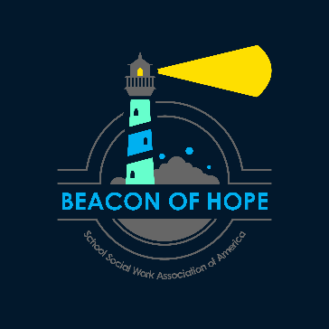
LIVE Full Conference – 11 CEUs available
LIVE Pre & Full Conference – 13 CEUs available
All Breakouts will have two options. Registering for live & on demand will allow the participant to attend both breakout sessions resulting in additional CEUs.
LIVE & on-demand access, the Full Conference - 20 CEUs available
LIVE & on-demand access, Pre & Full Conference - 24 CEUs available
ALL TIMES LISTED IN EASTERN TIME
Pre-Conference
Monday, March 22
6:30pm – 8:30pm Eastern (two options) 2.0 CEUs
Pre-Con Session A: Trauma-Informed Forum
Pre-Con Session B: SEL Forum

Full Conference
Tuesday, March 23

10:00 am – 11:00 am General Session (1.0 CEUs) Ethical Recordkeeping in the Internet Age
11:15 am -12:45 pm – Breakout A (two options) 1.5 CEUs
- A1: Building Belonging: Start with the Heart
- A2: Fine-Tuning Cultural Competence in Schools
LUNCH
1:15 pm – 2:45 pm – Breakout B (two options) 1.5 CEUs
- B1: Developmental Assets Mitigating the Impact of Adverse Childhood Experiences
- B2: School Social Workers as Border Crossers
3:00 pm – 4:30 pm – Breakout C (two options) 1.5 CEUs
- C1: Impact of Trauma on Refugee and Immigrant Families
- C2: The Art of Advocacy: Fundamental to Transforming Systems, Policies, and Practices
4:30 pm – 5:00 pm – National Award Presentations

Wednesday, March 24

10:00 am – 11:00 am General Session (1.0 CEUs) Discipline and School-wide PBIS through a Critical Race
Theory Lens
11:15 am -12:45 pm – Breakout D (two options) 1.5 CEUs
- D1: Best Practices for Supporting Staff and Students through Grief
- D2: An African-Centered Approach to School Social Work Practice
LUNCH
1:15 pm – 2:45 pm – Breakout E (two options) 1.5 CEUs
- E1: Art Based Interventions for Improving Social/Emotional Well Being
- E2: A Panel Discussion with LGBTQ+ Youth
3:00 pm – 4:30 pm – Breakout F (two options) 1.5 CEUs
- F1: Assessing Social-Environmental Risk and Protective Factors with the School Success Profile (SSP) 2020
- F2: Faith & Mental Health - Mental health professional competency in faith and religious beliefs
4:30 pm – 5:00 pm – Closing Announcements

