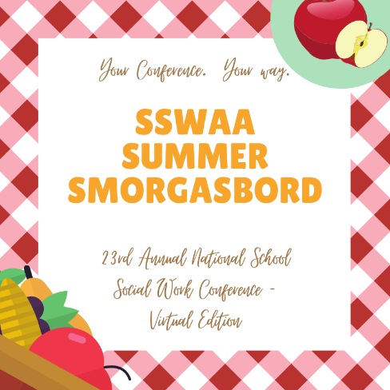
SSWAA is excited to provide the 23rd National Conference – Virtual Edition – in June! This event will provide School Social Workers with the opportunity to gain useful information and professional development training. The Virtual Conference will focus on important content around the COVID-19 pandemic and how to address related issues as School Social Workers plan to return to campus in the fall. Sessions will be available in a live format but also available to watch later "on demand." (through August 30th)

Virtual Conference Dates: Monday, June 29th and Tuesday, June 30th
Time: 10:00am – 5:00pm Eastern Time
#SSWAA2020virtual #YourConferenceYourWay
WHAT'S ON THE AGENDA?
The SSWAA 2020 National Virtual Conference will offer a literal "smorgasbord" of excellent topics related to practice issues around the ongoing COVID-19 pandemic. Confirmed topics include: SEL, grief & loss, trauma-informed strategies, telehealth, ethics, addressing inequity, planning with administrators, engaging parents, planning for the fall, and more! A general agenda is posted and more details will be shared soon!
FOR MORE INFORMATION and to register, go to: https://www.sswaa.org/virtual-conference
What if you cannot attend live on June 29th and 30th? No problem! The conference sessions will be hosted on June 29th and 30th including live chat and Q&A sessions with the speaker. Attend all sessions live or attend a select few live. You may also access recorded sessions to watch “on demand” through August 30th and take a post-test for CEU credit. It truly is, “Your Conference. Your Way.”
*This event is being submitted to NASW for CEU credit approval.
The COVID-19 pandemic has brought challenges for individuals, families, communities and organizations. SSWAA is partnering with states to try and help! SSWAA will be donating a portion of the event proceeds to states who participate. When you register, enter this promo code to help our state association: V20-NY

