UNITED FEDERATION OF TEACHERS
A Union of Professionals

52 Broadway
New York, NY 10004
www.uft.org

Michael Mulgrew
UFT President

Mary Jo Ginese
UFT Vice President
for Special Education

Raul D. Garcia
UFT Functional Chapter Leader
Social Workers and Psychologists

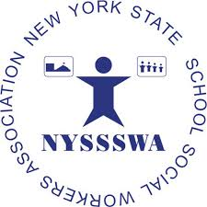 |  | 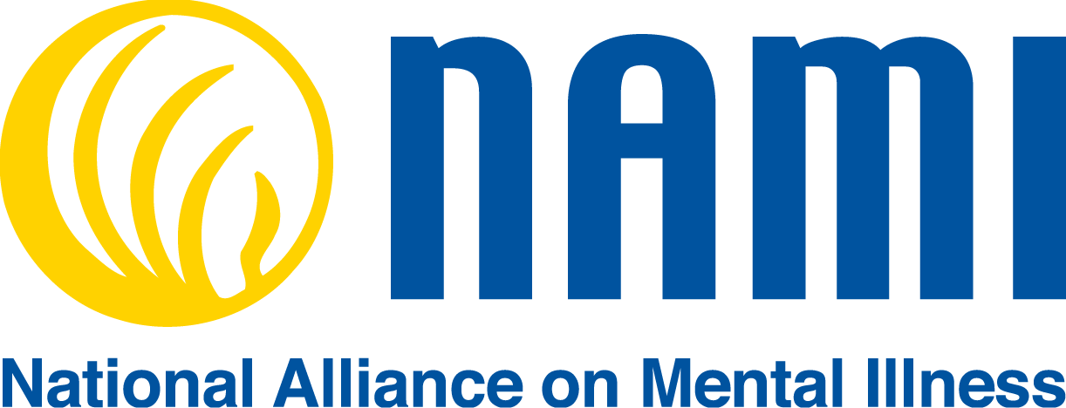
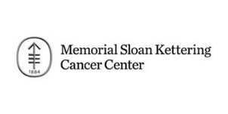

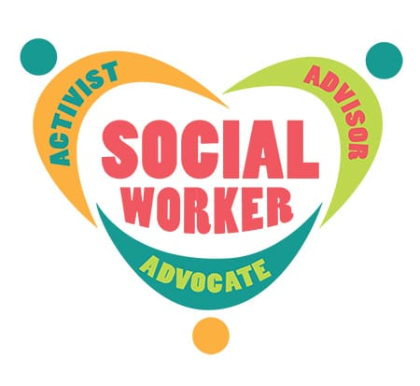

The 5th Annual
Social Worker Appreciation
Professional Development Day

March 3, 2020

Biography
Jessica Feldman MS, LMHC. CPRP Director of Programs and Services National Alliance on Mental Illness of NYC (NAMI-NYC)

Nina Rondow has a BA from Syracuse University and is a NAMI Ending the Silence Young Adult Presenter for NAMI-NYC Metro.

Almarie Tulloch has a BA from CUNY- York College, an AAS in Humana Services from CUNY – NY Technical College, a NAMI Ending the Silence Lead Presenter, and the Family Program Coordinator for NAMI-NYC Metro

Terri Sisson, Ed.S is a practicing school psychologist for 24 years and is currently an Educational Assessment Advisor for PAR, Inc. Terri has held several leadership positions in National Association of School Psychologist and is the current president of the Virginia Academy of School Psychologists (VASP). She was selected as the VASP School Psychologist of the Year in 2011 and was awarded the 2017-18 Community Partnership Award from James Madison University for her support of JMU graduate students.

Evelyn Attia, M.D. is the Director of the Columbia and Weill Cornell Center for Eating Disorders and the Metropolitan Comprehensive Care Centers for Eating Disorders. She is a Professor of Clinical Psychiatry at Weill Cornell Medical College and Professor of Psychiatry at Columbia University Irving Medical Center. She is the Clinical Director of the New York State Psychiatric Institute, and a distinguished researcher and clinician.

Jim Witmer, LCSW is the Health Project Coordinator with the Western NY Comprehensive Care Center for Eating Disorders and coordinator of School Based Project ECHO Eating Disorders.

Linda Mathew, LCSW is a practicing CBT, ACT and Palliative and End of Life Clinical Social Worker.
Meredith Cammarata, LCSW-R is a practicing CBT, a Clinical Hypnotist, a Palliative Care and End of Life and Ackerman Institute trained family Clinical Social Worker
David Sarfati is a practicing Meaning Centered Psychotherapist, Palliative Care with a- risk populations and Trauma Focused CBT Clinical Social Worker.

Morning
8:00 AM Registration
8:45 AM Opening Remarks
Raul D. Garcia - Chapter Leader - Social Worker and Psychologist Chapter
Don Albright - Chapter Liaison / UFT Special Representative

9:00 AM Greetings
LeRoy Barr - UFT Secretary
9:15 AM Eating Disorders: The Role of the School Social Worker
Evelyn Attia, MD, Columbia Center for Eating Disorders
Jim Witmer, Health Project Coordinator Project ECHO
Youth Mental Health Matters: Increasing Mental Health Literacy in Our School Based Communities
National Alliance on Mental Illness (NAMI). Community Education and Outreach Manager and Parent Advocate, Jessica Feldman, Nina Rondon and Almarie Tulloch.
The School Social Worker’s Toolkit for Creating Trauma-Sensitive Schools
Terri Sisson, Ed.S.. – Educational Assessment Advisor at PAR

Lunch
New York State School Social Worker Association
Julie Beatrice, LCSW – NYC Regional Representative

Afternoon
1:00 PM Talking with Children About Cancer
Linda Mathew, LCSW-R- Memorial Sloan Kettering (MSK) Oncology
Meredith Cammarata, LCSW-R - Memorial Sloan Kettering (MSK) Oncology
David Sarfati, LCSW - Memorial Sloan Kettering (MSK) Oncology
2:50 PM Closing Remarks

