SCHOOL SOCIAL WORKERS …

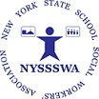

#NYSSSWA, #SchoolSocialWork, #SISPinSchools, #SchoolMentalHealth
New York State School Social Workers’ Association https://nyssswa.org/

