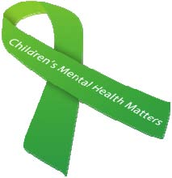
SCHOOL SOCIAL WORKERS CARE ABOUT…

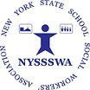

#SchoolSocialWork, #MentalHealthMatters, #SISPinSchools, #SchoolMentalHealth
New York State School Social Workers’ Association https://nyssswa.org/

