NY Assemblyman Ortiz Presents Bill for More School Social Workers
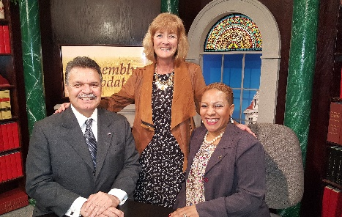
On February 12, 2018, NY Assembly Assistant Speaker Félix W. Ortiz held a press conference to introduce New York Assembly Bill A09533-A (which is the same as S7526-A: Senate version sponsored by NY Senator Jesse Hamilton) that requires access “to at least one full-time licensed or certified school social worker to be employed in each elementary, intermediate, middle, junior high school and senior high school” in New York State.

Assemblyman Ortiz was both personable and knowledgeable about School Social Workers and their role in the schools. Ortiz stated: “Certified social workers are the ‘gatekeepers’ for our youth, adolescents, and young adults’ education to help guide their future successes. Many of these students face problems that require professional help. Early intervention is the most effective way to prevent difficulties later in life.” Senator Hamilton noted “Mental health, emotional health and wellness all matter to educating our children. A parent fearing eviction, violence at home or in the community, any number of circumstances can impact a child’s ability to learn. School social workers have the expertise to help children, help families, and help our communities address these needs.”

Among other things, Ortiz focused on the critical mental health needs of our children in schools touching on cyberbullying, the impact of social media on children's’ daily lives and the alarming incidences of suicide among our children. He provided personal accounts from discussing these issues with his own children and grandchildren and stated ”We must assist teachers in shouldering burdens that they are not trained to handle while at the same time educating full classes”. Samantha Howell Esq. Executive Director of NASW-NY commented that “providing licensed Social Workers to students will ensure that they have a safe place to seek help and address any problems they face”. See the NYSSSWA/NASW joint Press Release for more details.
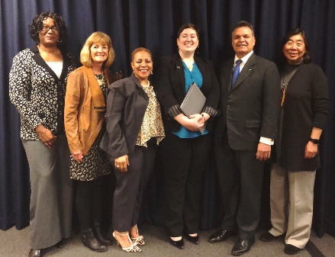
I was excited to participate at this event along with Hai-Ping Yeh, NYSSSWA Past President; Kelly Hannon Nichols, NYSSSWA Legislative Chair and Evelyn Bautista-Miller, bilingual School Social Worker from N.Y.C. As part of the Press Conference, representatives from NYSSSWA, NASW and NASW N.Y. all highlighted the critical need for School Social Workers, sharing data as well as personal accounts of their experiences underscoring the dire mental health needs of our children today.

Also, specifically noted was the 2017 report from the New York State Council of Superintendents which indicated that 45% of the superintendents cited the “capacity to help students in meeting non-academic needs including, for example, health and mental health issues” as the most widely significant problem they are dealing with. Furthermore, the Council’s Financial Survey reported that 52% of superintendents chose mental health and related services as one of their leading funding priorities.
After the press conference, we traveled to meet with Senator Carl Marcellino's office, Chair of the Senate's Committee on Education and met with staff to discuss the need for more School Social Workers and then to Assemblywoman Catherine Nolan's office (Chair of the Assembly's Committee on Education for further discussion on the same topic. The staffers took copious notes and shared personal experiences of awareness of School Social Workers in their own school careers. Later that day, we participated in a radio/T.V. show hosted by Assemblyman Félix Ortiz at which Ms. Bautista-Miller participated as the Spanish bilingual representative and I participated in English.
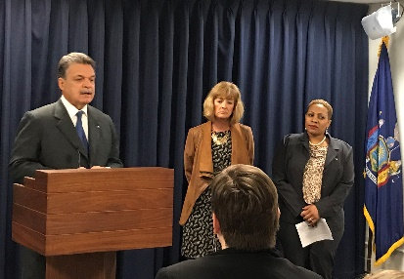
This bill comes amid an alarming number of violent school incidents and school administrations’ concerns related to keeping pace with the mental health needs of students. So far this year there have been approximately seven school shootings, as reported by the Tampa Bay Times, and that is more than one per week in 2018! As we mourn the unbelievable tragedy of 17 students being killed in Florida on Valentine’s Day, we applaud Assistant Speaker Ortiz and Senator Hamilton for moving beyond awareness and actually taking action to invest in the mental health needs of our students!

We will keep you posted regarding the developments of this bill and will issue a “Call for Action” when it is time for you to contact your local legislators for their support. In the meantime, let your administrators and School Superintendents know as well. See our NYS Legislative News and State Advocacy pages for updates and resources.

As members of NYSSSWA, we thank you for providing the membership funds and support we need to pursue these critical advocacy efforts on your behalf! We also thank you for all you are doing to support our most vulnerable, complex, and challenging students. Please stay safe.

Peg Barrett NYSSSWA President

