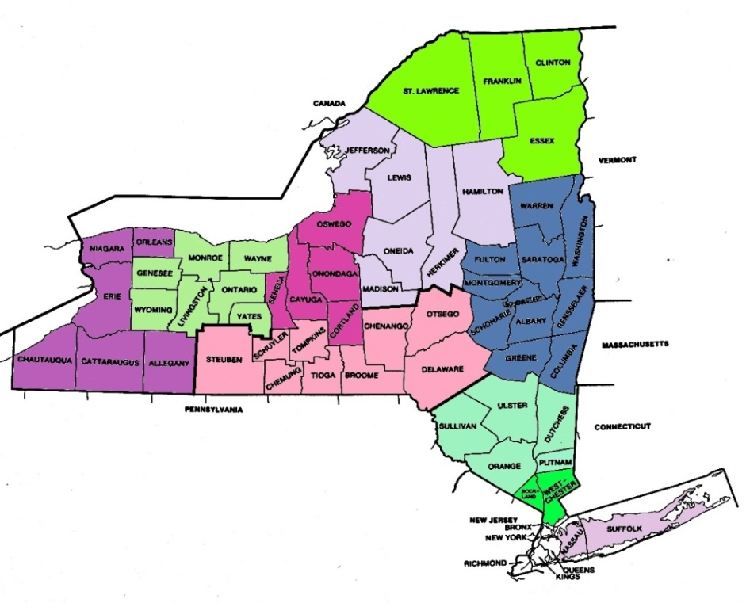
NYSSSWA Regions

Buffalo/Western Region
Allegany
Chautaqua
Cattaraugus
Erie
Niagara
Orleans

Capitol Region
Albany
Columbia
Fulton
Greene
Montgomery
Rensselaer
Saratoga
Schenectady
Schoharie
Warren
Washington

Mid Hudson Region
Dutchess
Orange
Putnam
Sullivan
Ulster

Mohawk Valley Region
Hamilton
Herkimer
Jefferson
Lewis
Madison
Oneida

Nassau/Suffolk Region
Nassau
Suffolk

New York City Region
Bronx
Kings (Brooklyn)
New York City (Manhattan)
Queens
Richmond (Staten Island)

Northern Region
Clinton
Essex
Franklin
St. Lawrence

Rochester Region
Genessee
Livingston
Rochester Region Cont.
Monroe
Ontario
Wayne
Wyoming
Yates

Southern Tier
Broome
Chemung
Chenango
Delaware
Otsego
Schuyler
Steuben
Tioga
Tompkins

Syracuse Region
Cayuga
Cortland
Onondaga
Oswego
Seneca

Westchester Region
Rockland
Westchester

